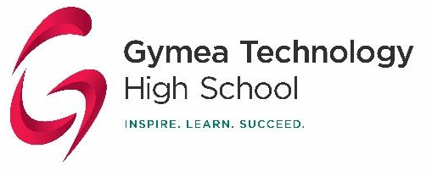 |  | HSIE  Year 7 History  Task 1: Skills Test

7G (Mrs. O’Farrell) – Period 4 – Room 48 7Y (Ms. Corry) – Period 2 – Room 47
7M (Ms.Corry) – Period 1 – Room 47 7E (Mr Burrell) – Period 3 – Room 48
7A (Ms Aleksoski) – Period 2 – Room 48

Task Name: Skills Test | Unit: Investigating the Ancient Past
Task Distributed: 7th August 2024 | Task Due: 22nd August 2024 (Week 5A)
Task Type: Online Skills Exam | Syllabus Outcomes: HT4.2, HT4.5, HT4.9
Task Weighting: 25% | Task number for Course: 1
Task Description:
This is an online skills test on Moodle. You need to have your Moodle log in and make sure you can access the Year 7 History page. The preparation for, and completion of, this task will ensure that students are able to successfully use historical sources to complement their own knowledge.

The test consists of multiple choice, true/false and matching questions. Students will be asked a range of questions on the content covered in class so far:
- Historical terminology and concepts
- Chronology
- Timelines
- Primary and secondary sources
- The role of historians and archaeologists
- The out-of-Africa-theory

NESA Glossary of Key Words
- Analyse: Identify components and the relationship between them; draw out and relate implications
- Explain: Relate cause and effect; make the relationships between things; provide why and/or how
- Understand the verb associated with the task. The verb will provide an understanding of the detail needed to successfully answer the question.
- Check the NESA Glossary of Key Words https://educationstandards.nsw.edu.au/wps/portal/nesa/11-12/hsc/hsc-student-guide/glossary-keywords

Details of Submission:

This is an in-class online test on Moodle. Students will complete this task in the technology centre during their History period on the scheduled date (see below).

Period 1: Room 47 – 7M – Ms. Corry
Period 2: Room 47 – 7Y – Ms. Corry
Period 2: Room 48 – 7A – Ms. Aleksoski
Period 3: Room 48 – 7E – Mr. Burrell
Period 4: Room 48 – 7G – Ms. O’Farrell

Students will use their Moodle log in to access the test, please check that you can access Moodle and make sure you can access the Year 7 History page.

c
Assessment Procedures
All students should be fully aware of the school assessment procedures. Students should access their 2024 Assessment Guide for more information.
Feedback provided
- Students will receive the mark for their test immediately.
- Feedback including information on how to improve will be provided through Moodle.
- Students can clarify or seek further feedback by speaking with their teacher or the assessment marker.
Self-Reflection Component
Students will be required to complete a self-reflection worksheet at the time students receive their assessment mark and teacher feedback. Self-reflection is an important part of the learning process as it provides an opportunity to reflect on the strength of your performance, as well as areas that have been identified to strengthen in future tasks.
What Areas of Learning will this Assessment Task Report On?
In this task you will be assessed on your ability to:

- Apply your skills in source analysis and demonstrate your knowledge of key historical concepts and vocabulary

These skills are the foundation upon which future studies of History depend.

